**Selected Topics CS 2**

Project name: SPA-GAN

Team no. : 49

|  |  |  |
| --- | --- | --- |
| **Name** | **ID** | **Grade** |
| رودينه مؤمن محمد بهاء الدين | 202000338 |  |
| منى عادل كمال عبد النبي | 202000952 |  |
| ساندي نادر شفيق | 202000383 |  |
| مينا زاهر شهاد | 202000970 |  |
| عبدالرحمن محمد عبد العزيز ابو المجد | 202000525 |  |
| احمد علي صلاح | 202000055 |  |

**Paper Details**

**Citation:**

Emami, H., Aliabadi, M. M., Dong, M., &amp; Chinnam, R. B. (2020, December 30). Spa-gan: Spatial attention gan for image-to-image translation. arXiv.org. Retrieved May 5, 2023, from <https://arxiv.org/abs/1908.06616>

**Dataset:**

Benchmark datasets

Evaluation on:

Horse ↔ Zebra

Apple ↔ Orange

Lion ↔ Tiger dataset

**Algorithm**

The SPA-GAN (Spatial Attention GAN) which is an image-to-image translation method needs to detect areas of interest in the input image and learn how to translate the detected areas into the target domain. In an unsupervised setting with no paired images between the two domains, one must pay attention to the areas of the image that are subject to transfer. The task of locating areas of interest is more important in applications of image-to-image translation where the translation should be applied only to a particular type of object rather than the whole image.

**Results**

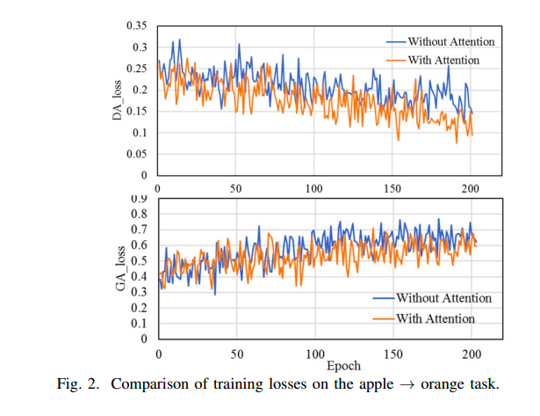

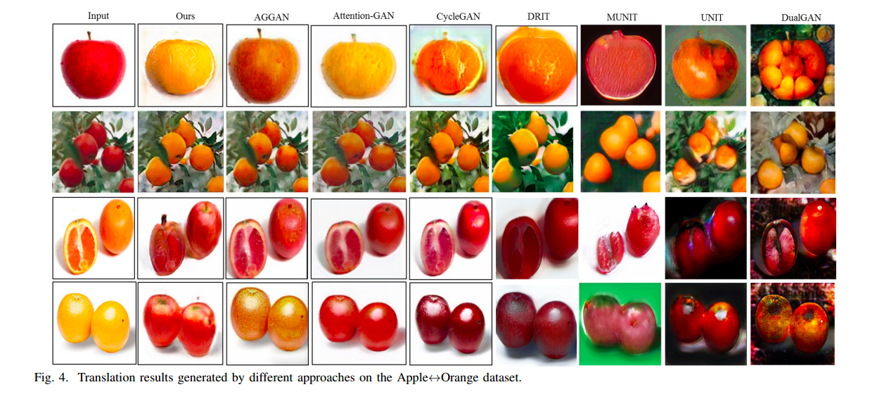

**Project Description**

1. General information on selected dataset

Dataset:

Name🡪 facades

<https://people.eecs.berkeley.edu/~taesung_park/CycleGAN/datasets/>

Total number of samples🡪 506 Building Facades & corresponding Segmentations with split into train and test subsets.

Image Size🡪 256x256

Implemented Algorithm:

SPA-GAN algorithm

1. Implementation Details

Block Diagrams

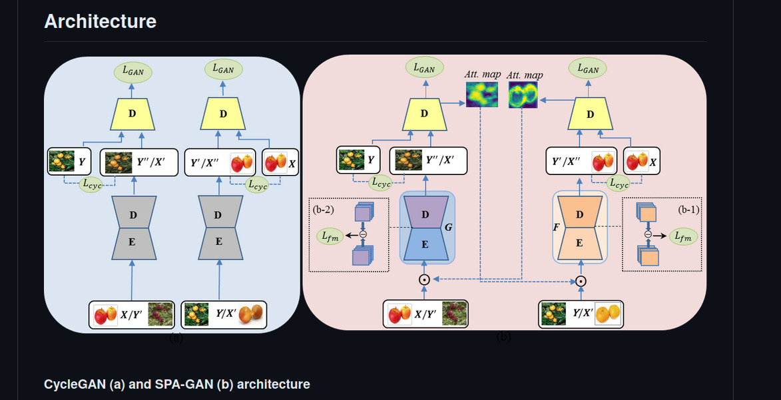General architecture of SPA-GAN

Discriminator

Hyperparameters:

Epochs = 80

Lr = 0.0002

Optimizer => Adam

Beta1 = 0.5

Beta2 = 0.999

1. Results Details

Generator total loss

While training:

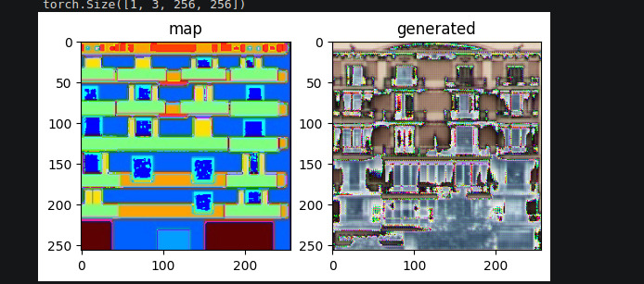

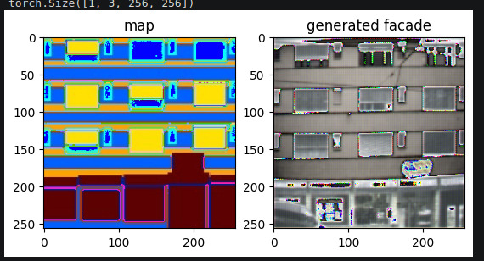After training:

Clean KID = 0.345